
  - Multi-Factor Authentication User Experience

Benefitfocus Access Guide

Table of Contents
What is Multi-Factor Authentication? 2
Login Experience with Multi-Factor Authentication 3
All Roles (Log-in with username and password) 3
Initial Login 3
Authentication Method: Authenticator App 4
Authentication Method: Phone 6
Authentication Method: Email 9
Updating MFA Method and/or Login Credentials 11
Username Recovery 12
Password Reset 14

What is Multi-Factor Authentication?
To further protect client data, Benefitfocus is introducing Multi-Factor Authentication (MFA) for Eligibility & Enrollment and Billing & Payments in 2025. MFA adds an extra layer of security by requiring a second step to verify a user’s identity, helping safeguard accounts and support Payment Card Industry (PCI) compliance.
When MFA is enabled, users will choose a verification method: email, text, voice, or an authenticator app, and enter a code sent via that method. They will then create a new, unique password.

Login Experience with Multi-Factor Authentication

All Roles (Log-in with username and password)

Initial Login
- User accesses the sponsor’s URL and enters their existing login credentials, username, and password.
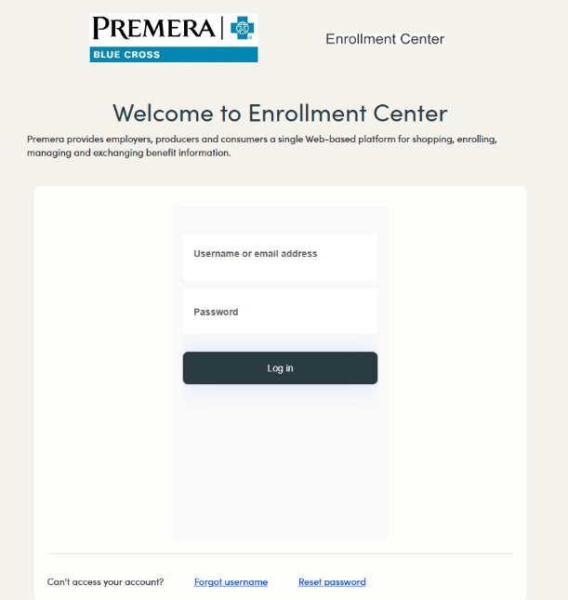

- User is prompted to select an authentication method from the drop-down menu; authentication options include an Authenticator app, phone, or email. User can click the What’s multi-factor authentication? link for more information on MFA and the available options.

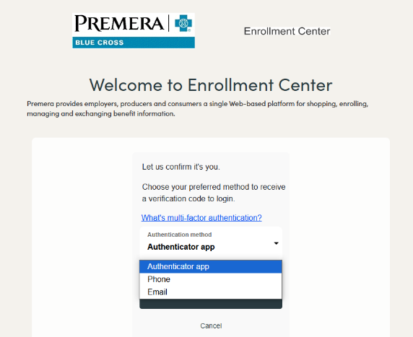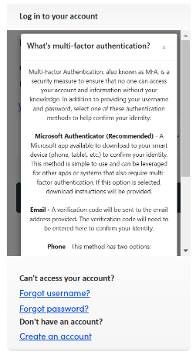

Authentication Method: Authenticator App
- User selects Authenticator app as their preferred method and selects Continue.
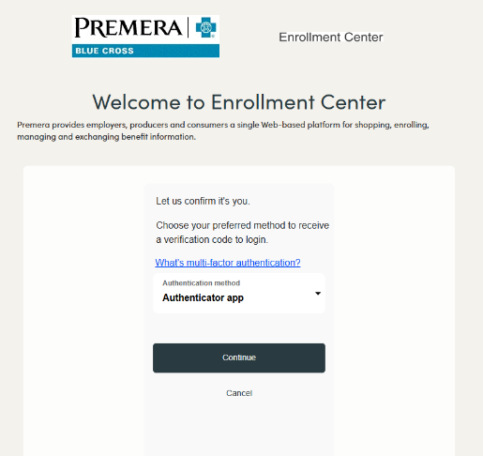
- Users are prompted to open their authenticator app, scan the displayed QR code, and follow the instructions. Users can click the How to use Authenticator app for detailed instructions on how to download and use an authenticator app and/or how to connect their Benefitplace account to an existing authenticator app.

If the user is not able or prefers not to scan the QR code, they can click Can’t scan? Enter code manually link below the QR code. User then clicks Continue.

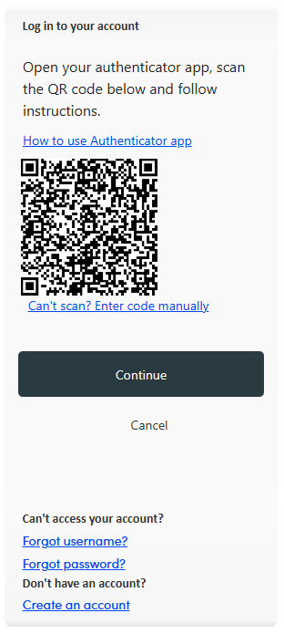

- User enters the code displayed in their authentication app and selects Verify.
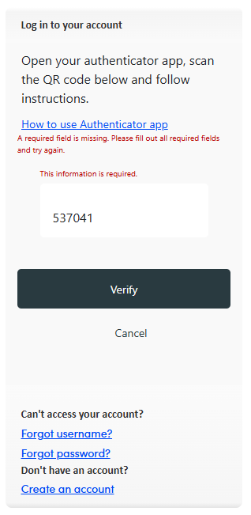
- Because this is the user’s initial log in, they will be prompted to reset their password after successfully verifying their identity via their selected authentication method.

If the entered password does not meet the security requirements, an error message is displayed with the password requirements.

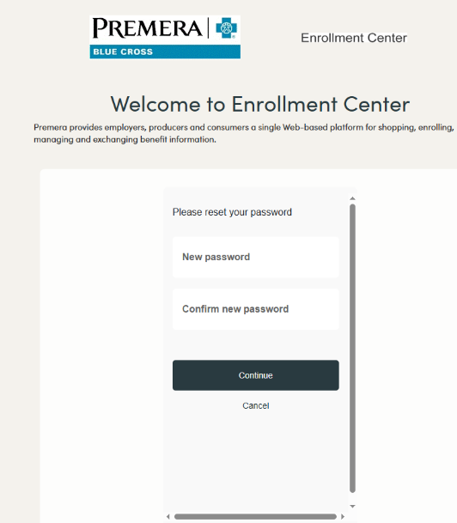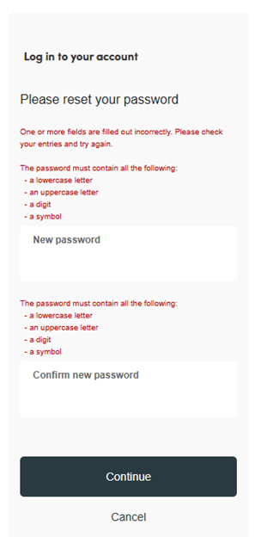
- Upon entering a password that meets the security requirements, the user is brought to their Benefitplace homepage.

Authentication Method: Phone
- User selects Phone as their authentication method and clicks Continue.
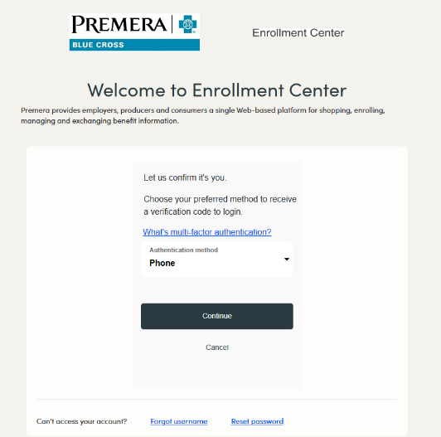
- Users select their Country Code from the drop-down menu. If Benefitplace has a phone number on file, it will be prepopulated in the Phone Number section. If both a work and personal phone number are on file, the work phone number will be displayed.

If a phone number is prepopulated, the user has the option to enter a different phone number of their choosing. The phone number does not have to be on file with Benefitplace to use it to authenticate.

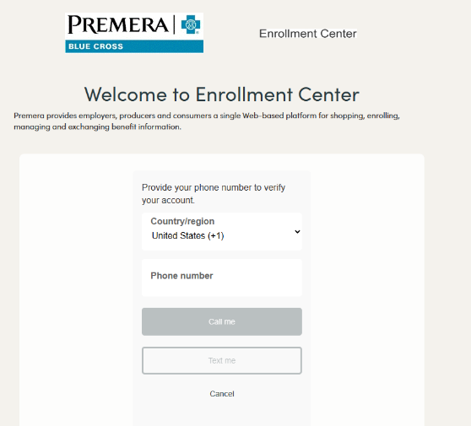

- After entering a phone number, the user will be prompted to choose whether to receive a text message with a code or a phone call to authenticate.

  - If the Send Code is selected, a text message with a passcode is sent to the phone number entered in the step above. User enters the code and selects Verify Code.
  - If Call Me is selected, an automated voice call is made to the phone number provided; the user will then be prompted to press pound (#) to complete authentication.
- If the user takes too long to enter the code, an error will be displayed, and the user will be prompted to select the Send new code button to receive a new code. User enters a valid code and selects Verify code.
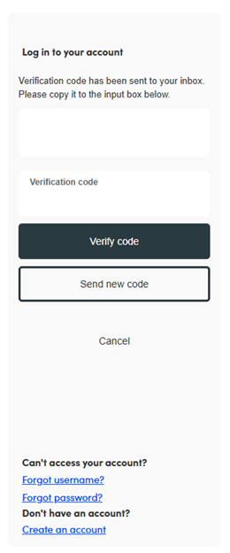
- Because this is the user’s initial log in, they will be prompted to reset their password. If the entered password does not meet the security requirements, an error message is displayed with the password requirements.
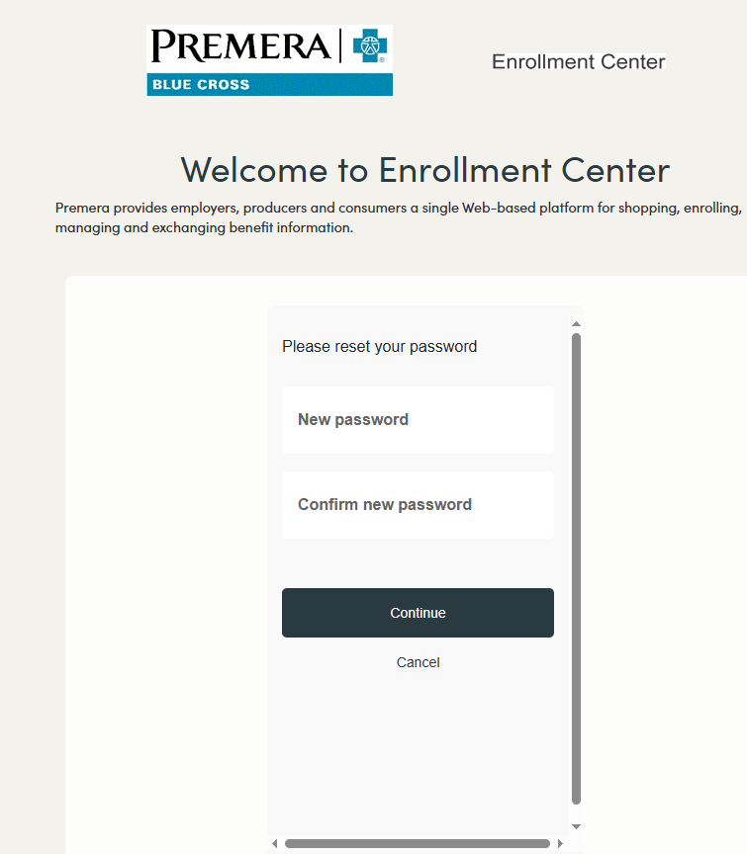
- Upon entering a password that meets the security requirements, the user is brought to their Benefitplace homepage.

Authentication Method: Email
- User selects Email as their authentication method and clicks Continue.
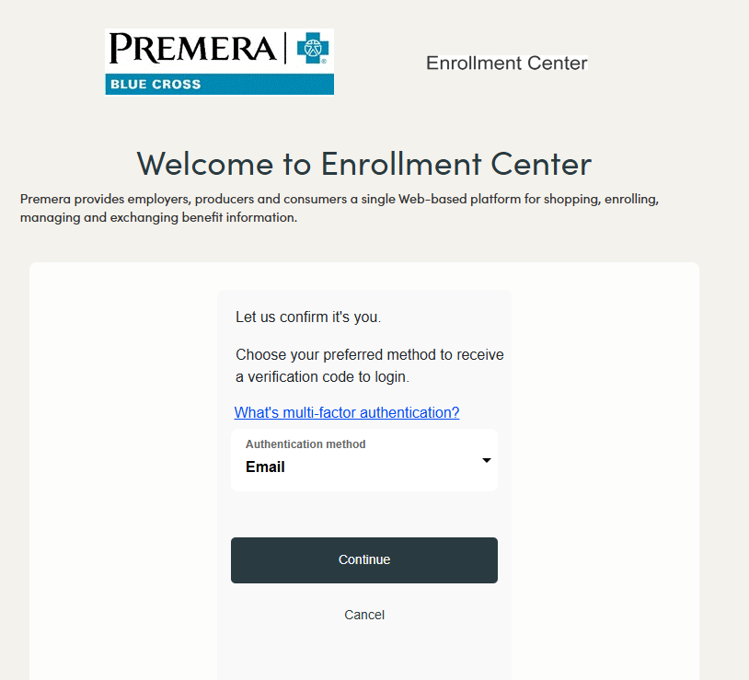
- If Benefitplace has an email address on file, it will be prepopulated in the Email Address box. If a work and personal email address are on file, the work email address will be displayed.
If an email address is prepopulated, the user has the option to enter a different email address of their choosing.

The email address does not have to be on file with Benefitplace to use it to authenticate. User selects Send verification code, and a verification code will be emailed.
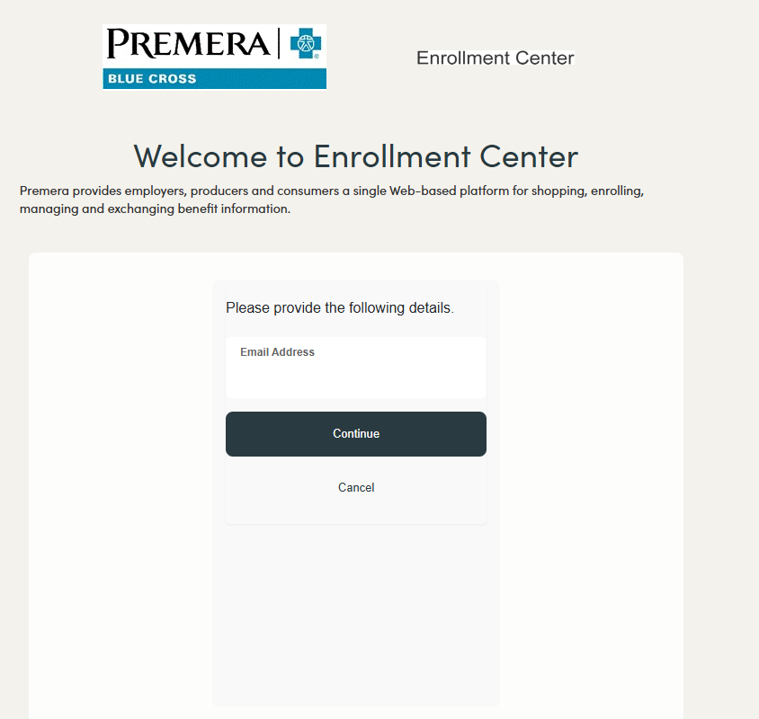
- If the user takes too long to enter the code, an error will be displayed, and the user will be prompted to select the Send new code button to receive a new code. User enters a valid code and selects Verify code.

- Because this is the user’s initial log in, they will be prompted to reset their password. If the entered password doesn’t meet the security requirements, an error message is displayed with the password requirements.
- Upon entering a password that meets the security requirements, the user is brought to their Benefitplace homepage.

Self-Service Options
Users have the ability to easily update and recover their login credentials and/or change their authentication method.

Updating MFA Method and/or Login Credentials
- From the Benefitplace homepage, the user clicks the Profile tab at the top right of the page and then selects the Login Information link. 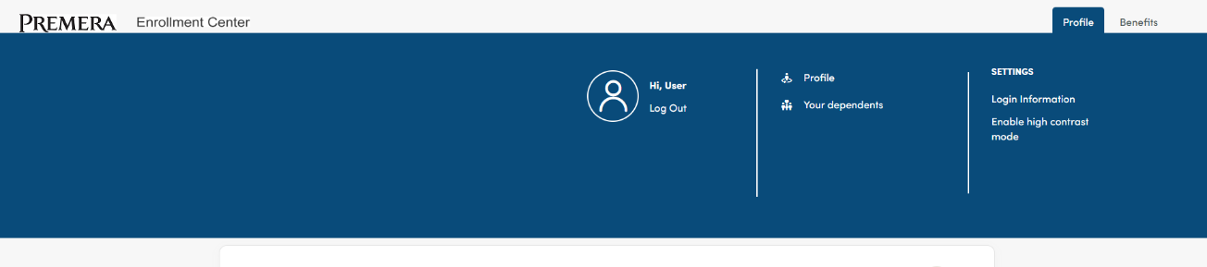
- From the Your Account page, the user can select a new MFA method and/or update their username, email address, phone number and/or password used to authenticate and login.
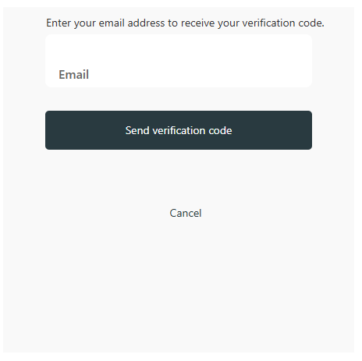
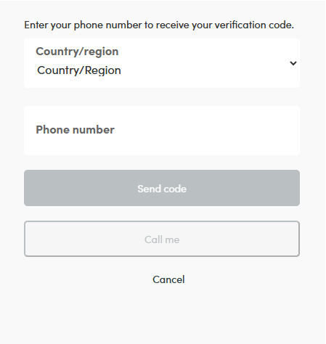
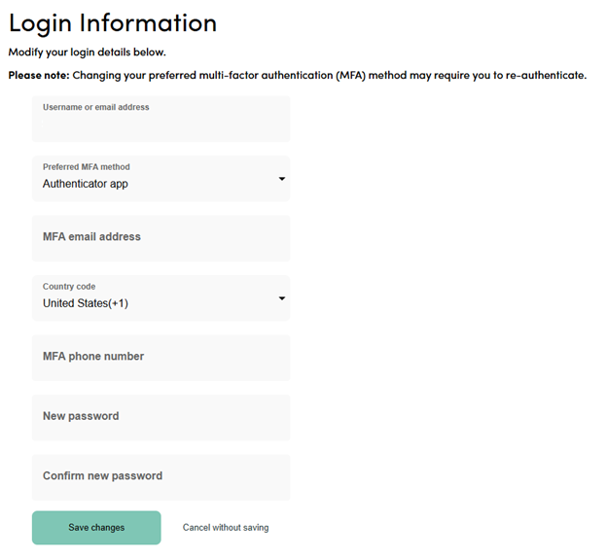

Username Recovery
- To recover a username, user selects the Forgot username? link at the bottom of the login page.
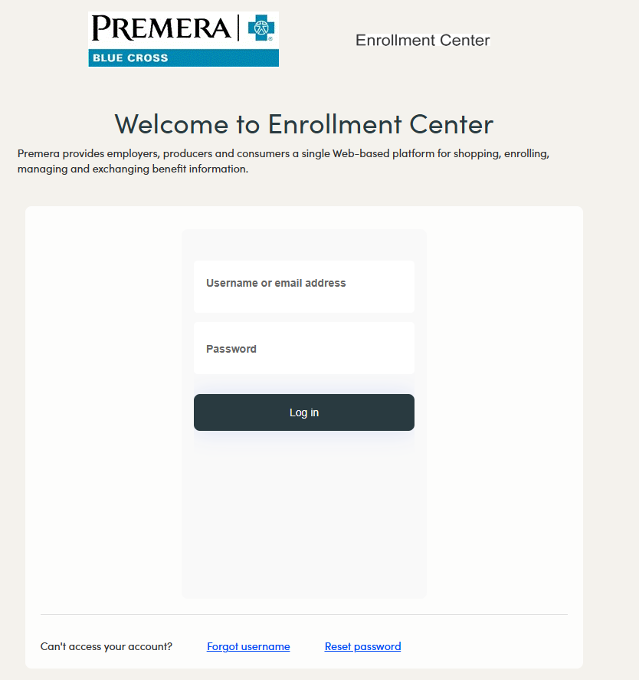
- User selects their appropriate user type and clicks Next.
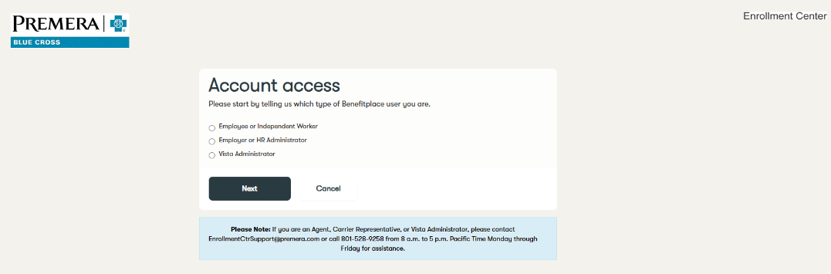
- User enters their identifying information, checks the Security Check checkbox, and clicks Next.
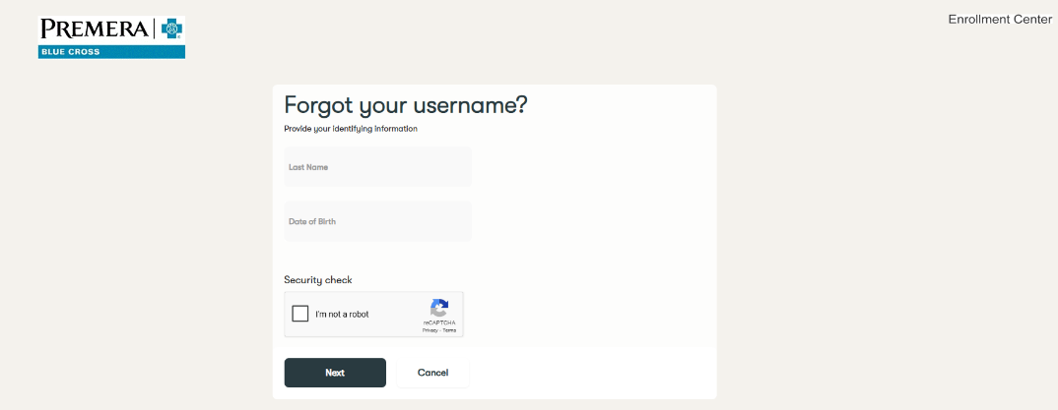

- The user’s username is displayed; user selects Back to Login to continue.
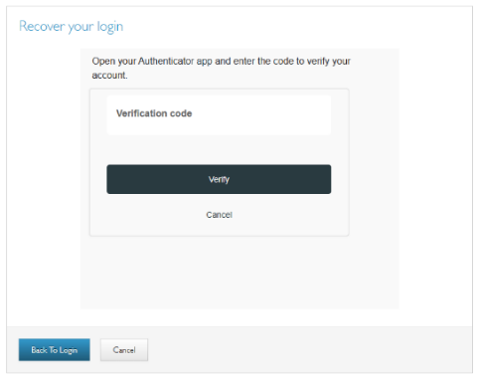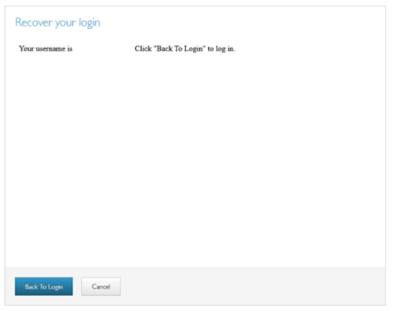

- Users are brought back to the login page to enter their username and password.
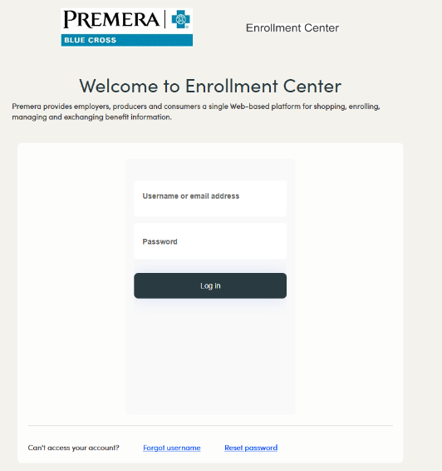

Password Reset
- To reset a password, user selects the Forgot password? link at the bottom of the login page. Please note: Carrier Representatives are not able to use the “Reset Password” functionality.
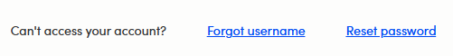
- User selects their appropriate user type and clicks Next.
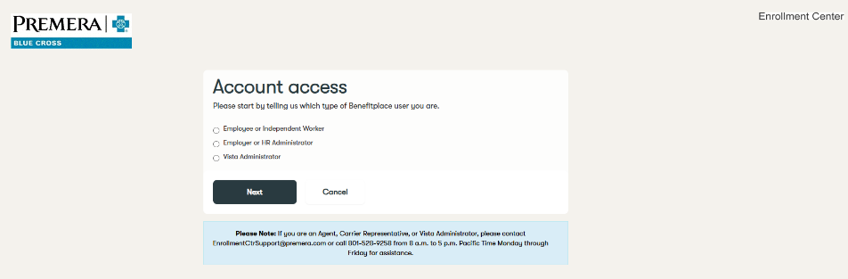
- User enters their identifying information, checks the Security Check checkbox, and clicks Next.
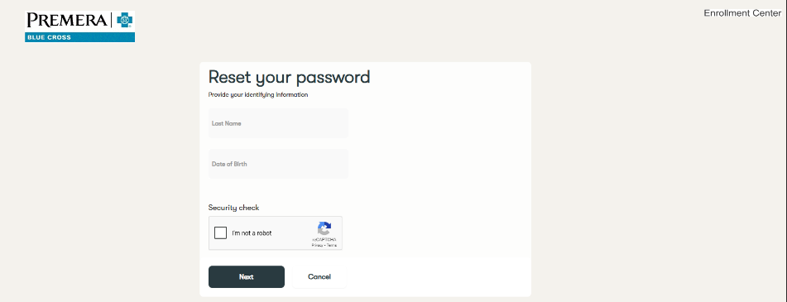
- User enters their username or email address and selects Continue.
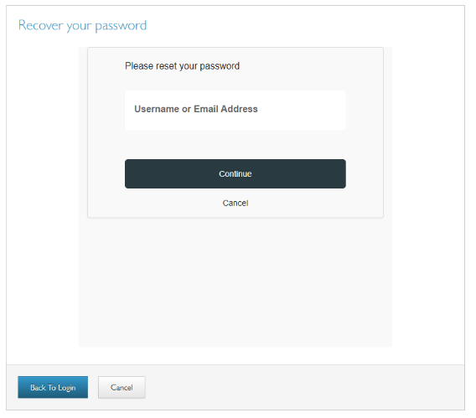
- Because the user has already established their MFA method, they will be prompted to complete verification; the steps to verify vary depending on the authentication method selected.

In the example below, the user selected an authenticator app as their verification method. The user opens the authenticator app, enters the code displayed, and clicks Verify.

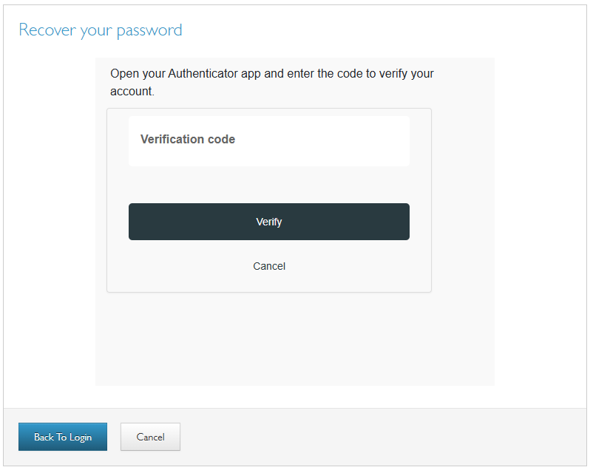
- User enters and re-enters a new password and clicks Continue. 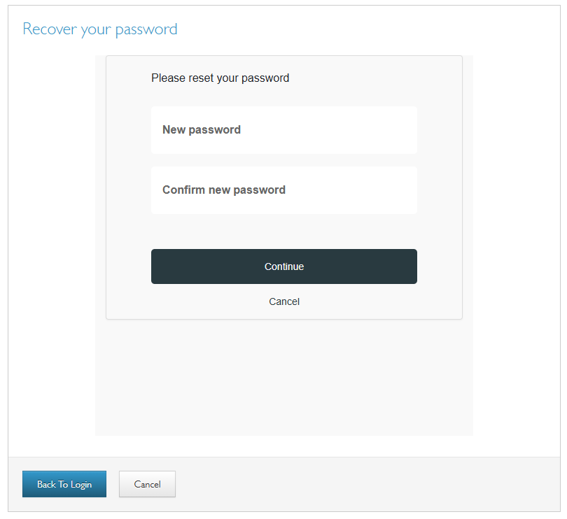
- User is prompted to return to the login page to login with the new password.

